**Write a command using ls to list all files (including hidden files) in the current directory and its subdirectories.**

**Modify the previous command to display only files with a specific extension (e.g., .txt). Enhance the report by including the file size for each listed file.**

**Further refine the output to display only files modified within the last 24 hours.**

**Combine the functionalities from points 2 and 4 to list only files with a specific extension (e.g., .jpg) modified in the last day.**

Certainly! Let's break down the commands step by step to achieve each requirement.

1. List all files (including hidden files) in the current directory and its subdirectories: ls -Rla
   * `-R`: Recursively list subdirectories encountered.
   * `-l`: Use a long listing format.
   * `-a`: Include directory entries whose names begin with a dot (.).
2. List files with a specific extension (e.g., `.txt`): find . -type f -name "*.txt" -exec ls -lh {} +
   * `find .`: Start from the current directory (`.`).
   * `-type f`: Only find files (not directories).
   * `-name "*.txt"`: Match files with the `.txt` extension.
   * `-exec ls -lh {} +`: Execute `ls -lh` on each found file (`{}` is replaced by the found files).
3. Include file size in the output:

The `-l` option in `ls -lh` already includes the file sizes in a human-readable format.

1. List files modified within the last 24 hours: find . -type f -mtime -1 -exec ls -lh {} +
   * `-mtime -1`: Find files modified less than 24 hours ago (`-1` means within the last day).
2. List files with a specific extension modified in the last day (e.g., `.jpg`): find . -type f -name "*.jpg" -mtime -1 -exec ls -lh {} +

name "*.jpg"`: Match files with the `.jpg` extension. mtime -1`: Find files modified less than 24 hours ago.

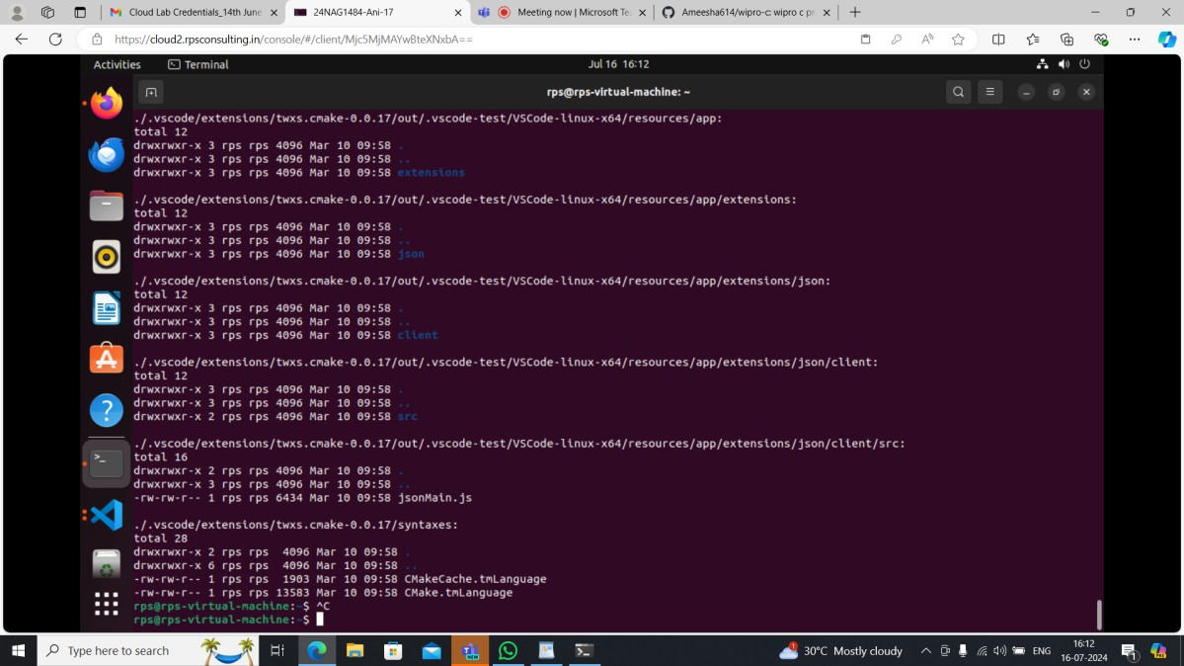

**dir/ls (5) :**

**Use dir / ls to list all files and folders in your current directory. How many files are there? (Excluding hidden files if applicable)**

**Utilize dir / ls with appropriate flags to display only files with a specific extension (e.g., .txt). How many files of that type exist?**

**Navigate to your Downloads folder using cd. Then, use dir / ls to list the contents. Are there any recently downloaded files (modified today)?**

**Use dir / ls with flags to display both the filename and its size for each file in your current directory. Identify the largest file.**

**Practice using dir / ls with wildcards (e.g., dir *.docx) to list all files with a specific extension pattern (e.g., all Word documents).**

1. **List all files and folders in the current directory**

ls -al

* `-a`: Shows all files, including hidden ones (files starting with `.`)
* `-l`: Displays detailed information including permissions, size, owner, modification date, etc. dir /a

`/a`: Shows all files, including hidden ones.

1. **Count the number of files (excluding hidden files)**

ls -l | grep "^-" | wc -l

* + `ls -l`: Long listing format to include detailed information.
  + `grep "^-"`: Filters out non-file entries (directories, symbolic links, etc.).
  + `wc -l`: Counts the number of lines (which corresponds to the number of files). dir /a /-p /o:n /s | find /c /v ""

`/a`: Shows all files.

`/-p`: Skips displaying the header.

`/o:n`: Sorts the listing by name.

`/s`: Displays files in the current directory and all subdirectories.

`find /c /v ""`: Counts non-empty lines (each line corresponds to a file).

1. **Display files with a specific extension (e.g., .txt) and count them**

ls *.txt

* + Lists all files with `.txt` extension. dir *.txt
  + Lists all files with `.txt` extension.

1. **Check for recently modified files in the Downloads folder** Assuming you've navigated to the Downloads folder (`cd Downloads`): ls -lt | head -n 5

`-lt`: Sorts files by modification time, newest first (`-l` for long format, `-t` for sort by time).

`head -n 5`: Displays the top 5 files (most recent). dir /od /p

`/od`: Sorts files by date/time, oldest first.

`/p`: Pauses after each screen of information.

1. **Display filename and size for each file in the current directory and identify the largest file**

ls -lhS

`-h`: Makes file sizes human-readable (e.g., KB, MB).

-'S`: Sorts files by size, largest first. dir /o:-s

* `/o:-s`: Sorts files by size, largest first.

1. **Use wildcards to list files with a specific extension pattern**

ls *.docx

Lists all files with `.docx` extension. dir *.docx

* Lists all files with `.docx` extension.

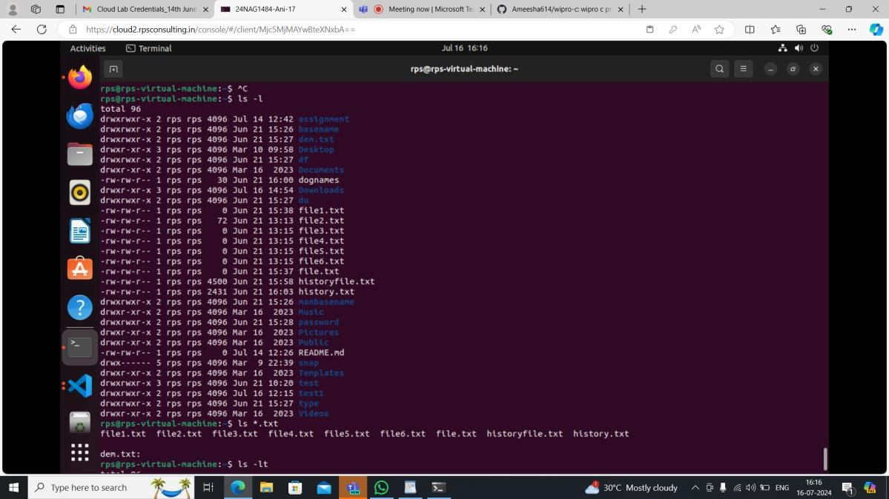

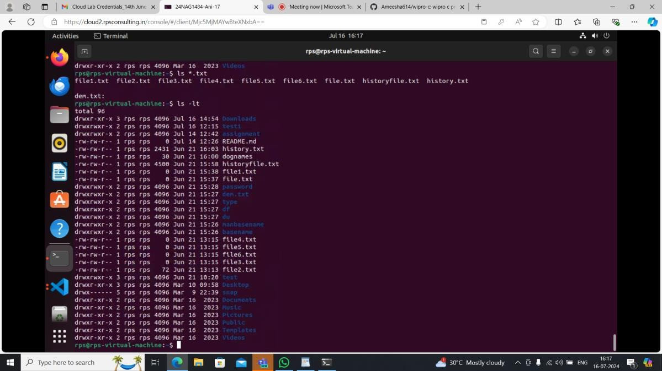

**cd (5):**

**Use cd to navigate to your Documents folder. What is the full path of your Documents folder displayed by the prompt?**

**Practice using cd .. to move back one directory level from your current location. Utilize pwd to display the full path of the current directory after navigating with cd.**

**Explore using directory shortcuts (e.g., ~ for home directory) with cd to quickly reach specific locations.**

**Combine cd with dir / ls to navigate to a specific folder and then list its contents.**

To accomplish the tasks using `cd` and related commands on a Unix-like system (such as Linux or

macOS), here’s how you can proceed:

1. **Navigate to the Documents folder:**

Assuming your Documents folder is located within your home directory (`~/Documents`), you can use the following commands:

cd # This brings you to your home directory (~) cd Documents # Navigate into the Documents folder

After executing these commands, your prompt should display the full path to the Documents folder.

For instance, if your username is `user`, the prompt might display something like:

/home/user/Documents $

1. **Use `cd ..` to move back one directory level:**

If you are currently inside the Documents folder and want to move back to your home directory: cd .. # Move back one directory level

This will take you back to your home directory. Your prompt will then display:

/home/user $

1. **Utilize `pwd` to display the current directory:**

`pwd` stands for "print working directory" and will display the full path of the current directory: pwd # Print the current directory path

For example, if you are in your home directory, it will display:

/home/user

1. **Explore using directory shortcuts with `cd`:**
   * `cd ~` or `cd` (without any arguments) takes you to your home directory.
   * `cd /` takes you to the root directory.
   * `cd -` switches between the current directory and the previous directory you were in.
2. **Combine `cd` with `ls` to navigate to a folder and list its contents:**

Suppose you want to navigate to the Documents folder and then list its contents: cd ~/Documents # Navigate to the Documents folder

ls # List the contents of the Documents folder

This will show you a list of files and directories within the Documents folder.

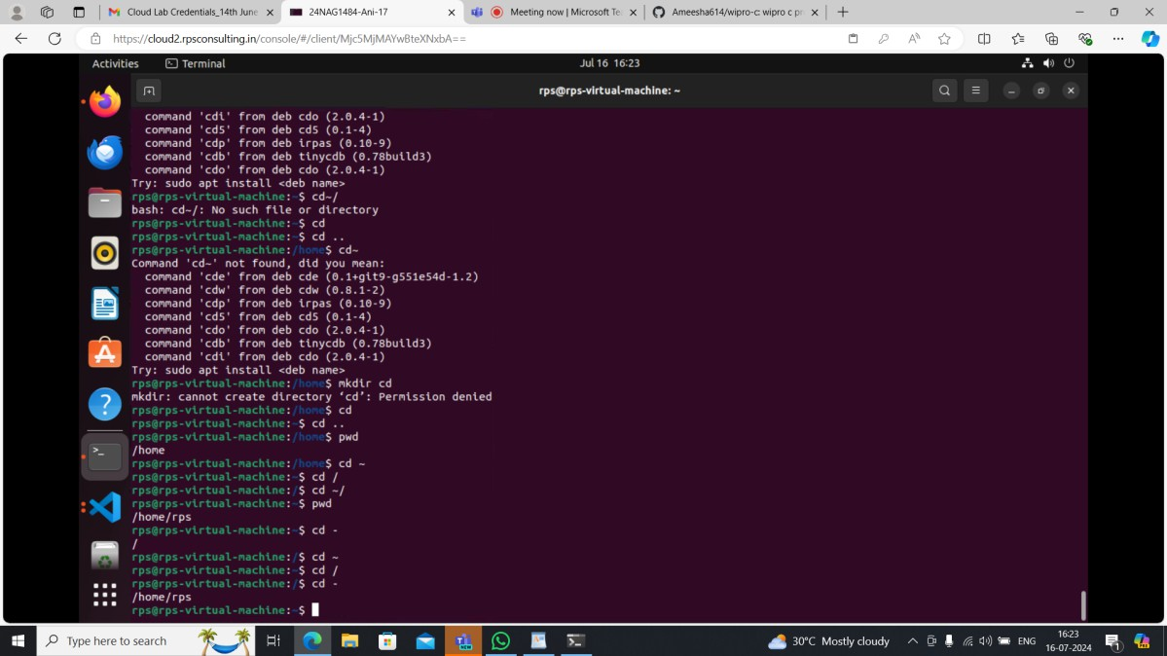

**cp / mv (5):**

**Identify a file on your Desktop. Use cp to copy that file to your Documents folder. Verify the copy exists in Documents.**

**Practice renaming a file on your Desktop using mv. Give it a new name and confirm the change using dir / ls.**

**Locate a folder containing images. Use cp to copy a specific image file from that folder to another folder.**

**Explore using mv to move a folder containing documents to a different location within your file system.**

**Try copying a file that already exists in the destination folder. What happens? (Experiment with different flags for cp if applicable on your system)**

**mkdir / rmdir (5):**

Sure, let's go through each part step by step.

**Part 1: Using `cp` to copy a file**

1. Identify a file on your Desktop : Let's say the file we want to copy is `example.txt` located on the Desktop.
2. Copy the file to your Documents folder : Open a terminal and use the `cp` command:

cp ~/Desktop/example.txt ~/Documents/

This command copies `example.txt` from the Desktop to the Documents folder.

1. Verify the copy : To verify that the file exists in the Documents folder, you can list the contents of the Documents folder:

ls ~/Documents/

You should see `example.txt` listed among the files in your Documents folder.

**Part 2: Using `mv` to rename a file**

1. Rename a file on your Desktop : Let's rename `example.txt` to `newname.txt` using the `mv` command:

mv ~/Desktop/example.txt ~/Desktop/newname.txt

This command renames `example.txt` to `newname.txt` on the Desktop.

1. Confirm the change : To confirm the file has been renamed, list the files on the Desktop: ls ~/Desktop/

You should see `newname.txt` listed instead of `example.txt`.

**Part 3: Using `cp` to copy an image file**

1. Locate a folder containing images : Assume there's a folder `~/Pictures/` that contains image files.
2. Copy a specific image file : Let's copy `photo.jpg` from `~/Pictures/` to `~/Documents/`: cp ~/Pictures/photo.jpg ~/Documents/

This copies `photo.jpg` from the Pictures folder to the Documents folder.

**Part 4: Using `mv` to move a folder**

1. Move a folder containing documents: Assume there's a folder `~/Documents/Reports/` that contains documents.
2. Move the folder to a different location: Let's move `Reports` from `~/Documents/` to `~/Desktop/ mv ~/Documents/Reports ~/Desktop/

This moves the entire `Reports` folder from Documents to the Desktop.

**Part 5: Handling existing files with `cp'**

1. Copying a file that already exists in the destination folder **:** If `example.txt` already exists in

`~/Documents/` and you try to copy it again: cp ~/Desktop/example.txt ~/Documents/

By default, `cp` will not overwrite the existing `example.txt`. It will give an error message like `cp: overwrite '~/Documents/example.txt'?`.

1. Using flags for `cp`: To force overwrite existing files without prompting, you can use the `-f` (force) flag:

cp -f ~/Desktop/example.txt ~/Documents/

This will overwrite `example.txt` in `~/Documents/` without asking for confirmation.

**Summary**

* `cp`: Used for copying files or directories.
* `mv`: Used for renaming files or moving files/directories.
* Pay attention to existing files when using `cp` to avoid accidental overwrites.
* Verify operations using `ls` or `dir` commands after each action to ensure desired changes have taken place.

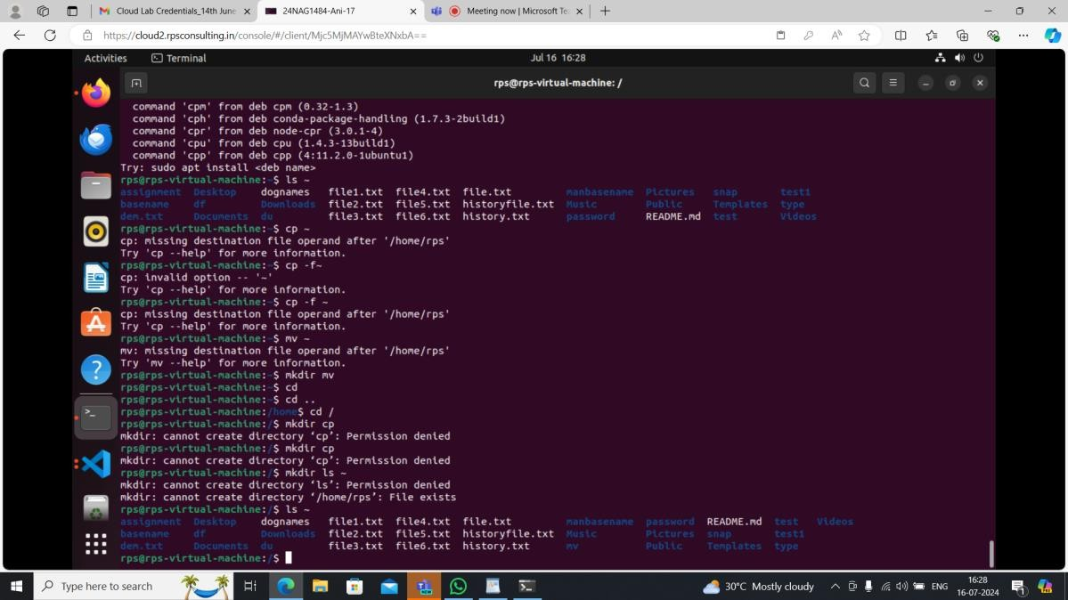

**mkdir / rmdir (5):**

**Create a new folder named "Project Reports" inside your Documents folder using mkdir. Verify its**

**existence using dir / ls.**

**Practice using mkdir with multiple arguments to create a nested folder structure (e.g., mkdir Documents/ProjectX/Reports).**

**Locate an empty folder you created earlier. Use rmdir to delete it. Confirm its removal with dir / ls. Explore using dir / ls to identify empty folders within a specific directory.**

1. **Create a new folder named "Project Reports" inside your Documents folder using mkdir. Verify its existence using dir / ls.**

Assuming you're on a Unix-like system (Linux or macOS), here's how you would do it: mkdir ~/Documents/Project\ Reports

* `mkdir`: Command to create a directory.
* `~/Documents/Project\ Reports`: Path to the new directory, where `~` represents your home directory. To verify its existence, you can use `ls` (on Unix-like systems) or `dir` (on Windows):

ls ~/Documents

dir C:\Users\YourUsername\Documents

Look for the "Project Reports" directory in the output to confirm it exists.

1. **Practice using mkdir with multiple arguments to create a nested folder structure (e.g., mkdir Documents/ProjectX/Reports).**

To create nested folders:

mkdir -p ~/Documents/ProjectX/Reports

* + `-p` option: Allows mkdir to create parent directories as needed.

This command creates the `ProjectX` directory inside `Documents`, and then the `Reports` directory inside `ProjectX`.

1. **Locate an empty folder you created earlier. Use rmdir to delete it. Confirm its removal with dir / ls.**

Find the folder you want to delete. Let's assume it's `~/Documents/EmptyFolder`. rmdir ~/Documents/EmptyFolder

* + `rmdir`: Command to remove a directory (it only works if the directory is empty). After running `rmdir`, confirm its removal:

ls ~/Documents

dir C:\Users\YourUsername\Documents Ensure that `EmptyFolder` is no longer listed.

1. **Explore using dir / ls to identify empty folders within a specific directory.**

To find empty folders within a directory (`~/Documents` for example): find ~/Documents -type d -empty

* + `find`: Command to search for files and directories.
  + `~/Documents`: The directory you want to search within.
  + `-type d`: Only search for directories.
  + `-empty`: Only find directories that are empty.

This command will list any empty directories within `~/Documents`.

